|  |
| --- |
|  |
| Sensory Guide |
| A guide intended to make it easier for parents to plan activities for children on the autism spectrum, by providing insight on how sensory processing issues may be affected. |
|  |
|  |
|  |

|  |
| --- |
| *Disclaimer: The assessors believe the information in this assessment report to be correct at the time of printing. The assessors do not accept responsibility for any consequences arising from the use of this information. This should not be relied upon as an exhaustive record of all possible risks or hazards that may exist or potential improvements that can be made.* |



**Animal Habitats**

**Sensory Guide**

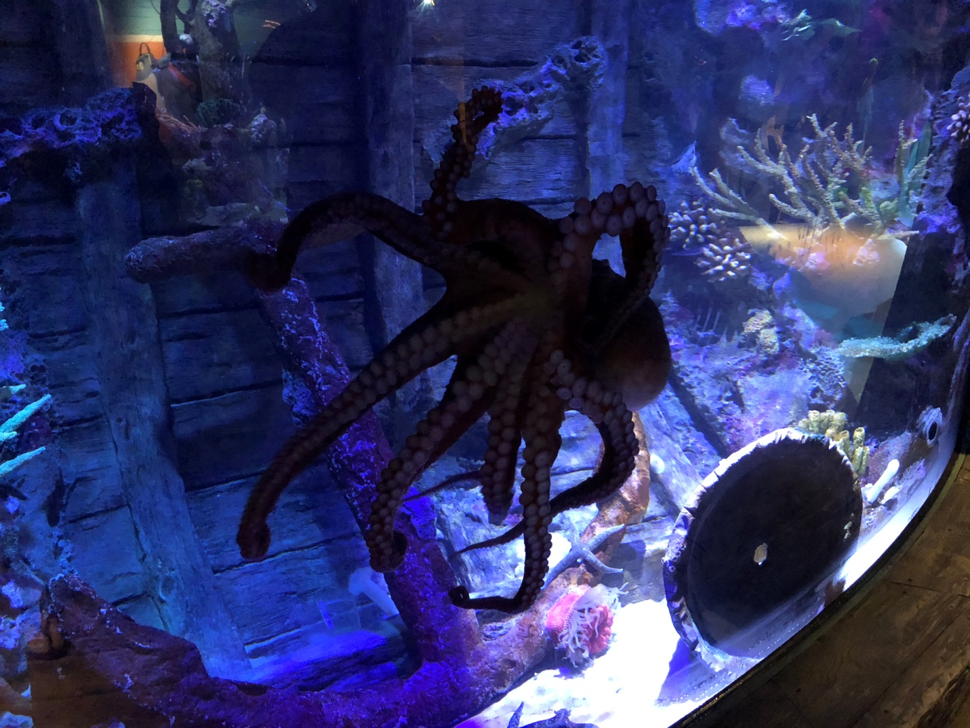

C:\Users\BNowak\Desktop\eye-open.png

**Ticket Desk**

This is the first habitat you see at arrival. The admissions area is where you will check in for your visit and purchase your tickets. You can choose to purchase a ranger pack here for extra fun throughout your visit!

* Don’t touch or climb into the habitat.
* Place hands by your side at all times.
* The coral décor and fish in the habitat as well as the assorted TVs in the admissions area may appear colorful to guests who are sensitive to colors.

Sensory Level *(1= low sensory stimulation, 5= high sensory stimulation)*

Animals to Check Out

Guest Guidelines/Tips

4

1

3

1

1

SIGHT

SMELL

SOUND

TASTE

TOUCH







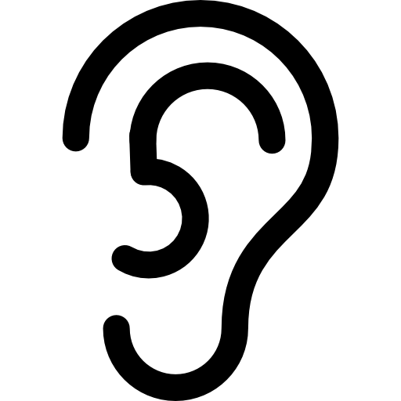





**SEA LIFE Orlando Aquarium Sensory Guide**

* Blue tang
* Angelfish
* Silver Moony
* Slipper Lobster

C:\Users\BNowak\Desktop\eye-open.png

**Photos**

This area includes a green screen where you and your family can take photos, but this is optional. Next, you will go down a hallway where you’ll get your Dive Log Books which guide you through your journey with interactive activities at certain habitat in the aquarium.

* None! This is just a stop to begin your aquarium journey.
* All photos are optional, and you can bypass at any time.
* Our Virtual Reality room is located in the hallway after the photo capture station.
* The colors in the photo room are a bit bright, which is why we rated it as a 3 for sight.

Sensory Level *(1= low sensory stimulation, 5= high sensory stimulation)*

Animals to Check Out

Guest Guidelines*/*Tips

3

1

1

1

1

SIGHT

SMELL

SOUND

TASTE

TOUCH













**SEA LIFE Orlando Aquarium Sensory Guide**

C:\Users\BNowak\Desktop\eye-open.png

* French angelfish
* Four-eyed butterflyfish
* Lookdowns
* North Atlantic kingfish
* Porkfish
* White grunts

Sensory Level *(1= low sensory stimulation, 5= high sensory stimulation)*

Animal to Check Out

Guest Guidelines/Tips

4

1

5

1

2

SIGHT

SMELL

SOUND

TASTE

TOUCH











**Shoaling Ring**

This is a semi-circle shaped room that features fishswimming in one direction. However, some fish tend to go the opposite direction occasionally.



**SEA LIFE Orlando Aquarium Sensory Guide**

* Don’t touch the habitat, and place hands by your side at all times.
* Some of the fish are shiny, so may be overwhelming for some.
* There are bubble machines in the habitat which helps the water current.
* **Warning:** The room echoes so sound can be very loud at times.

C:\Users\BNowak\Desktop\eye-open.png

* Spotted moray eel
* Red lionfish
* Chocolate chip sea stars
* Fire shrimp
* Hermit crabs
* Pajama cardinalfish
* Don’t touch the habitat, and place hands by your side at all times.
* Don’t climb on the rocks.
* Watch your head when going under the bubble for a closer view inside our habitats.
* You can look in the small habitats in the back, but be careful not to hit your head on the bubble habitats as they’re angled toward you.
* **Tip:** The moray eel loves to pose for pictures, and he stays very still, but if you look closely you can see him opening and closing his mouth as he breathes.

Sensory Level *(1= low sensory stimulation, 5= high sensory stimulation)*

Animals to Check Out

Guest Guidelines/Tips

3

1

2

1

5

SIGHT

SMELL

SOUND

TASTE

TOUCH











**Ocean Caves**

Walk down the tunnel from the shoaling ring into the underwater ocean caves. Meet all sorts of interesting fish from the Green Moray Eel to the Red Lionfish. You can even duck into our habitats for a fun picture and to see our fish up close.



**SEA LIFE Orlando Aquarium Sensory Guide**

C:\Users\BNowak\Desktop\eye-open.png

* Moon jellies
* Don’t touch the habitat, and place hands by your side at all times.
* **Note:** The buttons change the colors of the overhead lights, not the actual jellies. More so, the light changes the glow on the moon jellies.
* The colors will also change the jellyfish figures overhead.
* The hallway is a bit small and may feel confining to those who are claustrophobic.

Sensory Level *(1= low sensory stimulation, 5= high sensory stimulation)*

Animals to Check Out

Guest Guidelines/Tips

5

3

3

1

5

SIGHT

SMELL

SOUND

TASTE

TOUCH











**Jelly Wall**

As you turn the corner from the ocean caves, you’ll see the wall of jellyfish! This is another interactive zone for guests. Guests are encouraged to press the color buttons to change the glow of the moon jellies.



**SEA LIFE Orlando Aquarium Sensory Guide**

C:\Users\BNowak\Desktop\eye-open.png

Sensory Level *(1= low sensory stimulation, 5= high sensory stimulation)*

Guest Guidelines/Tips

4

2

5

1

3

SIGHT

SMELL

SOUND

TASTE

TOUCH











**Shark Shipwreck**

First, you’ll see the floor change to our wooden floor board. This area features our giant pacific octopus habitat, our wolf eels habitat, a glimpse into our Atlantic Ocean habitat, and several smaller habitats. This area is a bit chilly due to the octopus’ and wolf eels’ preferred temperatures.



**SEA LIFE Orlando Aquarium Sensory Guide**

* Don’t touch or climb over the habitats, and place hands by your side at all times. Don’t climb on the rocks.
* There’s a dramatic change in theming from vinyl to wood floors and much darker lighting in this area compared to the jelly wall.
* Be careful not to hit your head on the bubble habitat across from the wolf eels as it is a magnifying glass and will be bubbled toward you.
* **Warning:** To the right of the giant pacific octopus habitat is a shark interactive and it will be running as normal with sounds and movements if buttons are pressed.
* **Tip:** The octopus can be amazingly good at camouflage. If you can’t find her, she’s likely hiding in one of the corners of the habitat.
* **Tip:** The wolf eels usually like to sleep together in the pot in their habitat since they mate for life!

Animals to Check Out

* Wolf eels
* Giant pacific octopus
* Banggai cardinalfish
* Coral catsharks
* Anemones

C:\Users\BNowak\Desktop\eye-open.png

* Chely, green sea turtle
* Monty, kemp’s ridley sea turtle
* Zebra sharks
* Taylor, shovelnose guitarfish
* Mangrove whiprays
* Tarpon
* Gus, green moray eel
* Don’t touch the habitat, and place hands by your side at all times.
* Don’t climb on the rocks.
* The sharks and other fish can glide very close to the glass and it can be frightening to those with fear of quick-moving creatures or sharks specifically.
* **Tip:** Look in the waters above for Chely, our rescued green sea turtle.

Sensory Level *(1= low sensory stimulation, 5= high sensory stimulation)*

Animal to Check Out

Guest Guidelines/Tips

4

1

2

1

2

SIGHT

SMELL

SOUND

TASTE

TOUCH











**Atlantic Ocean**

Within the shark shipwreck, you’ll get to see your first glance into our Atlantic Ocean. Inside you’ll see Chely, our rescue green sea turtle, rays, a few zebra sharks, and so many more!



**SEA LIFE Orlando Aquarium Sensory Guide**

C:\Users\BNowak\Desktop\eye-open.png

* Axolotls
* Goldfish
* Kenyi chilclids
* Suckermouth catfish
* Blind cave fish
* Angelfish
* Don’t touch or climb over the habitat, and place hands by your side at all times.
* Watch your head when going under the bubble for a closer view inside our axolotl habitat.
* The colors in this area are the most vibrant throughout SEA LIFE, and it was rated as a 5 for sight for those who are sensitive to colors.
* You can smell the salt water a bit more than usual in this area as well.

Sensory Level *(1= low sensory stimulation, 5= high sensory stimulation)*

Animals to Check Out

Guest Guidelines/Tips

5

3

4

1

4

SIGHT

SMELL

SOUND

TASTE

TOUCH











**Axolotl Fiesta**

Take a turn into our Axolotl room to learn more about the superhero axolotls! You can even pop your head under the bubble in the axolotl habitat.



**SEA LIFE Orlando Aquarium Sensory Guide**

C:\Users\BNowak\Desktop\eye-open.png

* French grunt
* Orange shoulder tang
* Cleaner wrasse
* Purple tang
* Sassy, green moray eel
* Don’t touch the habitat, and place hands by your side at all times.
* Don’t climb on the rocks.
* Watch your head when going under the bubble for a closer view inside our tanks.
* Sound in this area can be louder than usual since it’s nearby the behind the scenes desk and the 180-degree tunnel and Pacific Ocean where families often stop for pictures.
* **Tip:** Going under the tunnels is optional, but it can be fun to watch the fish swim above you!

Sensory Level *(1= low sensory stimulation, 5= high sensory stimulation)*

Animals to Check Out

Guest Guidelines/Tips

2

1

4

1

2

SIGHT

SMELL

SOUND

TASTE

TOUCH











**Coral Sea**

After leaving the axolotl area, you’ll see a habitat that goes to the ceiling with some of our larger fish inside. Then, you’ll go into an area with two tunnels which you can either walk underneath or walk around. Fish surround you throughout the whole room!



**SEA LIFE Orlando Aquarium Sensory Guide**

C:\Users\BNowak\Desktop\eye-open.png

* None, but the Pacific Ocean is nearby with a ton of creatures to check out!
* More information is in later pages that go step by step through this entire experience!
* You can buy your tickets at the admission desk in the beginning of the attraction or here at the Behind the Scenes desk.
* There’s seating in this area for those who need it.

Sensory Level *(1= low sensory stimulation, 5= high sensory stimulation)*

Animals to Check Out

Guest Guidelines/Tips

3

2

4

1

1

SIGHT

SMELL

SOUND

TASTE

TOUCH











**Behind the Scenes**

If you want to enhance your experience even further, you can with our exclusive behind the scenes tour. For just $10, you can see how we take care of our animals, how we provide their food and life support, and you can see the ocean habitats from above!



**SEA LIFE Orlando Aquarium Sensory Guide**

C:\Users\BNowak\Desktop\eye-open.png

* Ellie, epaulette shark
* Chocolate chip sea star
* French grunt
* Unicornfish
* Bonnethead sharks
* Don’t touch or climb over the habitat, and place hands by your side at all times.
* Don’t climb on the rocks.
* **Warning:** There tends to be a small echo in the ocean tunnel, but it is not as loud as The Shoaling Ring.
* **Warning:** The light tends to move with the effect of the wave, so the glare changes as you walk through.
* Do not climb on any of the coral in the tunnel or outside of it, around the habitat view, etc.
* **Tip:** If you wait a bit, you might be able to see Chely or Monty swim above you!

Sensory Level *(1= low sensory stimulation, 5= high sensory stimulation)*

Animals to Check Out

Guest Guidelines/Tips

3

2

4

1

2

SIGHT

SMELL

SOUND

TASTE

TOUCH











**180° Tunnel/Pacific Ocean**

First, you’ll see our Pacific Ocean tank where tropical fish are floating all around! Then, you can enjoy 180-degree views of our ocean habitat, as you walk through our Ocean Tunnel. Sharks, rays, and fish love to swim above you as you walk below.



**SEA LIFE Orlando Aquarium Sensory Guide**

C:\Users\BNowak\Desktop\eye-open.png

**360° Ocean Tunnel**

Get ready to experience Florida’s only 360-degree ocean tunnel. After the 180-degree tunnel, you’ll walk into a small room beneath our med habitat. From here, you can see the clear tunnel ahead where fish can swim above your head and underneath your feet!

* Chely, green sea turtle
* Monty, kemp’s ridley sea turtle
* Zebra sharks
* Taylor, shovelnose guitarfish
* Mangrove whiprays
* Tarpon
* Gus, green moray eel

Sensory Level *(1= low sensory stimulation, 5= high sensory stimulation)*

Animals to Check Out

Guest Guidelines/Tips

5

1

4

1

3

SIGHT

SMELL

SOUND

TASTE

TOUCH













**SEA LIFE Orlando Aquarium Sensory Guide**

* Do not stomp on the floor of the tunnel or hit the glass sides as it can scare the fish.
* This area is very colorful as it has fish and live creatures swimming all around you, and it can be disorienting to some.
* **Warning:** There tends to be a small echo in the ocean tunnel, but it is not as loud as The Shoaling Ring.
* **Warning:** The light tends to move with the effect of the wave, so the glare changes as you walk through.

C:\Users\BNowak\Desktop\eye-open.png

* Lined seahorses
* Pot-bellied seahorses
* Hermit crabs
* Tiger snake eel
* Slipper lobster
* Bumble bee snail
* Don’t touch the habitat, and place hands by your side at all times.
* Don’t climb on the rocks.
* Seahorses may be hard to see due to their size, so you can feel free to get close to the habitat to see them correctly.
* The pot-bellied seahorses are alone in their habitat, but there are a few other creatures in the lined seahorse habitat.
* The habitat will have strong wave currents that keep our seahorses in a clean environment. There’s a little sound that accompanies it, but it’s not very loud.

Sensory Level *(1= low sensory stimulation, 5= high sensory stimulation)*

Animal to Check Out

Guest Guidelines/Tips

3

1

3

1

2

SIGHT

SMELL

SOUND

TASTE

TOUCH











**Seahorse Hideaway**

They may not be the largest, but they’re still mighty! There are two habitats here with two different types of seahorses. The fat ones are called pot-bellied seahorses and they aren’t pregnant.



**SEA LIFE Orlando Aquarium Sensory Guide**

C:\Users\BNowak\Desktop\eye-open.png

* Ted, loggerhead sea turtle
* Southern stingrays
* Cownose rays
* Hogfish
* Spotted unicornfish

Sensory Level *(1= low sensory stimulation, 5= high sensory stimulation)*

Animal to Check Out

Guest Guidelines/Tips

4

1

4

1

3

SIGHT

SMELL

SOUND

TASTE

TOUCH











**Indian Ocean**

Enter our Indian Ocean exhibit and meet Ted, the loggerhead sea turtle who was voted Orlando’s most loved animal!



**SEA LIFE Orlando Aquarium Sensory Guide**

* Don’t touch the habitat, and place hands by your side at all times.
* Don’t climb on the rocks.
* **Tip:** Look out for Ted, our loggerhead sea turtle. He’s usually swimming around or snapping at the very front of the exhibit. He helped test the T.E.D which saves sea turtles in Florida from fisherman’s traps.

C:\Users\BNowak\Desktop\eye-open.png

* Coral catsharks
* Yellow tangs
* Blue spotted rays
* American horseshoe crabs
* Don’t touch or climb over/into the habitat, and place hands by your side at all times.
* There is seating available for those who need it.
* If you go around to the back of the habitat, you can see the fish in a bubble carve-out for you to sit in.

Sensory Level *(1= low sensory stimulation, 5= high sensory stimulation)*

Animals to Check Out

Guest Guidelines/Tips

4

1

5

1

3

SIGHT

SMELL

SOUND

TASTE

TOUCH











**Feeding Frenzy**

Welcome to our haven for coral catsharks! Be transported into a tropical paradise with music, bright sights and even spot a horseshoe crab!



**SEA LIFE Orlando Aquarium Sensory Guide**

C:\Users\BNowak\Desktop\eye-open.png

* Don’t touch or climb over the habitat, and place hands by your side at all times.
* Don’t climb on the rocks.
* It can get a bit loud in this area if there are a lot of families in the coastal rockpool and/or feeding frenzy.
* **Tip:** The turtles are all very active in the cylinder-shaped habitat at the front of the room.
* **Tip:** Make sure to check out the small circular habitats on the floor as they house our crawfish that have been bred onsite.

Sensory Level *(1= low sensory stimulation, 5= high sensory stimulation)*

Animals to Check Out

Guest Guidelines/Tips

4

1

4

1

2

SIGHT

SMELL

SOUND

TASTE

TOUCH











**Everglades**

Here we welcome you to Florida’s call to fame, The Everglades! Lighting has a green tint in here to reflect the forest-like atmosphere. The room houses our only freshwater creatures.



**SEA LIFE Orlando Aquarium Sensory Guide**

* Darcy, softshell turtle
* Diamondback terrapins
* Mangroves
* Cuban hogfish
* Yellowhead wrasse

C:\Users\BNowak\Desktop\eye-open.png

* Bat sea stars
* Ochre sea stars
* Strawberry anemones
* White-spotted rose anemones

Sensory Level *(1= low sensory stimulation, 5= high sensory stimulation)*

Animals to Check Out

Guest Guidelines/Tips

4

1

5

1

5

SIGHT

SMELL

SOUND

TASTE

TOUCH











**Coastal Rockpool**

On our last stop, you’ll actually be able to touch some of our coolest creatures! Be careful and make sure to use the two-finger rule when you pet our sea stars and anemones.



**SEA LIFE Orlando Aquarium Sensory Guide**

* Touching is encouraged, but you must do a gentle, 2 finger touch on all animals.
* No climbing on the rocks or diving into the tanks.
* All animals must remain in the water at all times. No animal can be picked up out of the water.
* **Warning:** Given that this is a popular area it can get very loud, but the exit is nearby.
* **Warning:** Water is extremely cold at about 50°F to keep our creatures native to the Northwest Pacific Ocean safe and happy.
* You will need to stand in the designated spot in the station line to wait your turn, to allow plenty of space for each guest to touch. The screen above the area will give instructions.
* Make sure to rinse your hands with water before touching the creatures and we encourage you to wash your hands with soap after touching as well.



**Behind the Scenes**

**Sensory Guide**

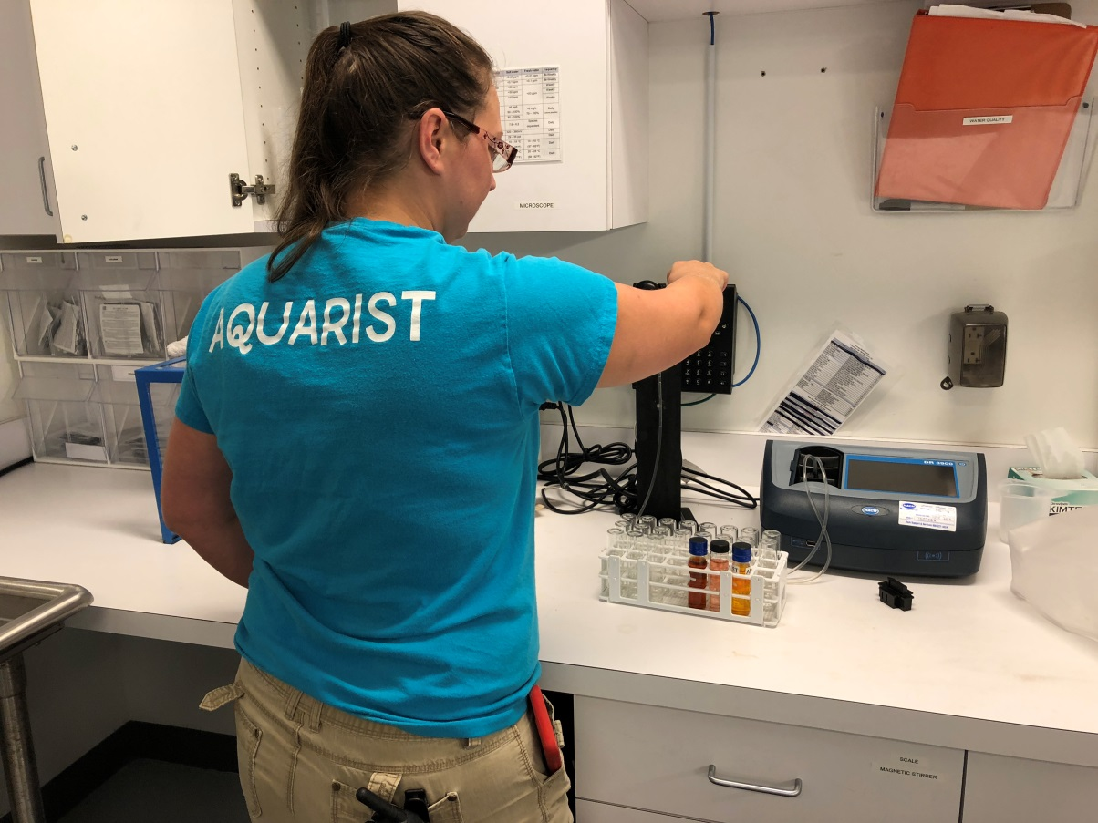

C:\Users\BNowak\Desktop\eye-open.png

* Ask any questions you have to the designated host.
* Other staff members may be moving in and out of this area frequently.
* **Warning:** Because of the kitchen area, it tends to smell “fishy” right after they prepare the food for the day.

Sensory Level *(1= low sensory stimulation, 5= high sensory stimulation)*

Guest Guidelines/Tips

3

5

4

1

2

SIGHT

SMELL

SOUND

TASTE

TOUCH











**Behind the Scenes: Life Support System**

This is the first stop on our Behind the Scenes tour. This section discusses the system we filter our water through and how it varies across the different habitats depending on the animals are in it.



**SEA LIFE Orlando Aquarium Sensory Guide**

C:\Users\BNowak\Desktop\eye-open.png

* Ask any questions you have to the designated host.
* **Warning:** The lights are bright in this area to allow aquarists plenty of light to work.
* **Warning:** Because of the kitchen area, it tends to smell “fishy” right after they prepare the food for the day.
* **Note:** There are emergency kits on the wall. Do not touch.

Sensory Level *(1= low sensory stimulation, 5= high sensory stimulation)*

Guest Guidelines/Tips

2

5

4

1

5

SIGHT

SMELL

SOUND

TASTE

TOUCH











**Behind the Scenes: Food Preparation**

This is the second stop on our Behind the Scenes tour. Here, your tour guide will discuss what aquarists feed our animals and how they manage the different animals’ feeding schedules.



**SEA LIFE Orlando Aquarium Sensory Guide**

C:\Users\BNowak\Desktop\eye-open.png

* Ask any questions you have to the designated host.
* Do not pick up the shark teeth or jaw.
* **Warning:** The lights are bright in this area to allow aquarists plenty of light to work.
* **Warning:** Because of the kitchen area, it tends to smell “fishy” right after they prepare the food for the day.

Sensory Level *(1= low sensory stimulation, 5= high sensory stimulation)*

Guest Guidelines/Tips

3

5

4

1

3

SIGHT

SMELL

SOUND

TASTE

TOUCH











**Behind the Scenes: Laboratory**

This is the third stop on our Behind the Scenes tour. Here, your tour guide will discuss how we take care of our animals and some of their natural habits.



**SEA LIFE Orlando Aquarium Sensory Guide**

C:\Users\BNowak\Desktop\eye-open.png

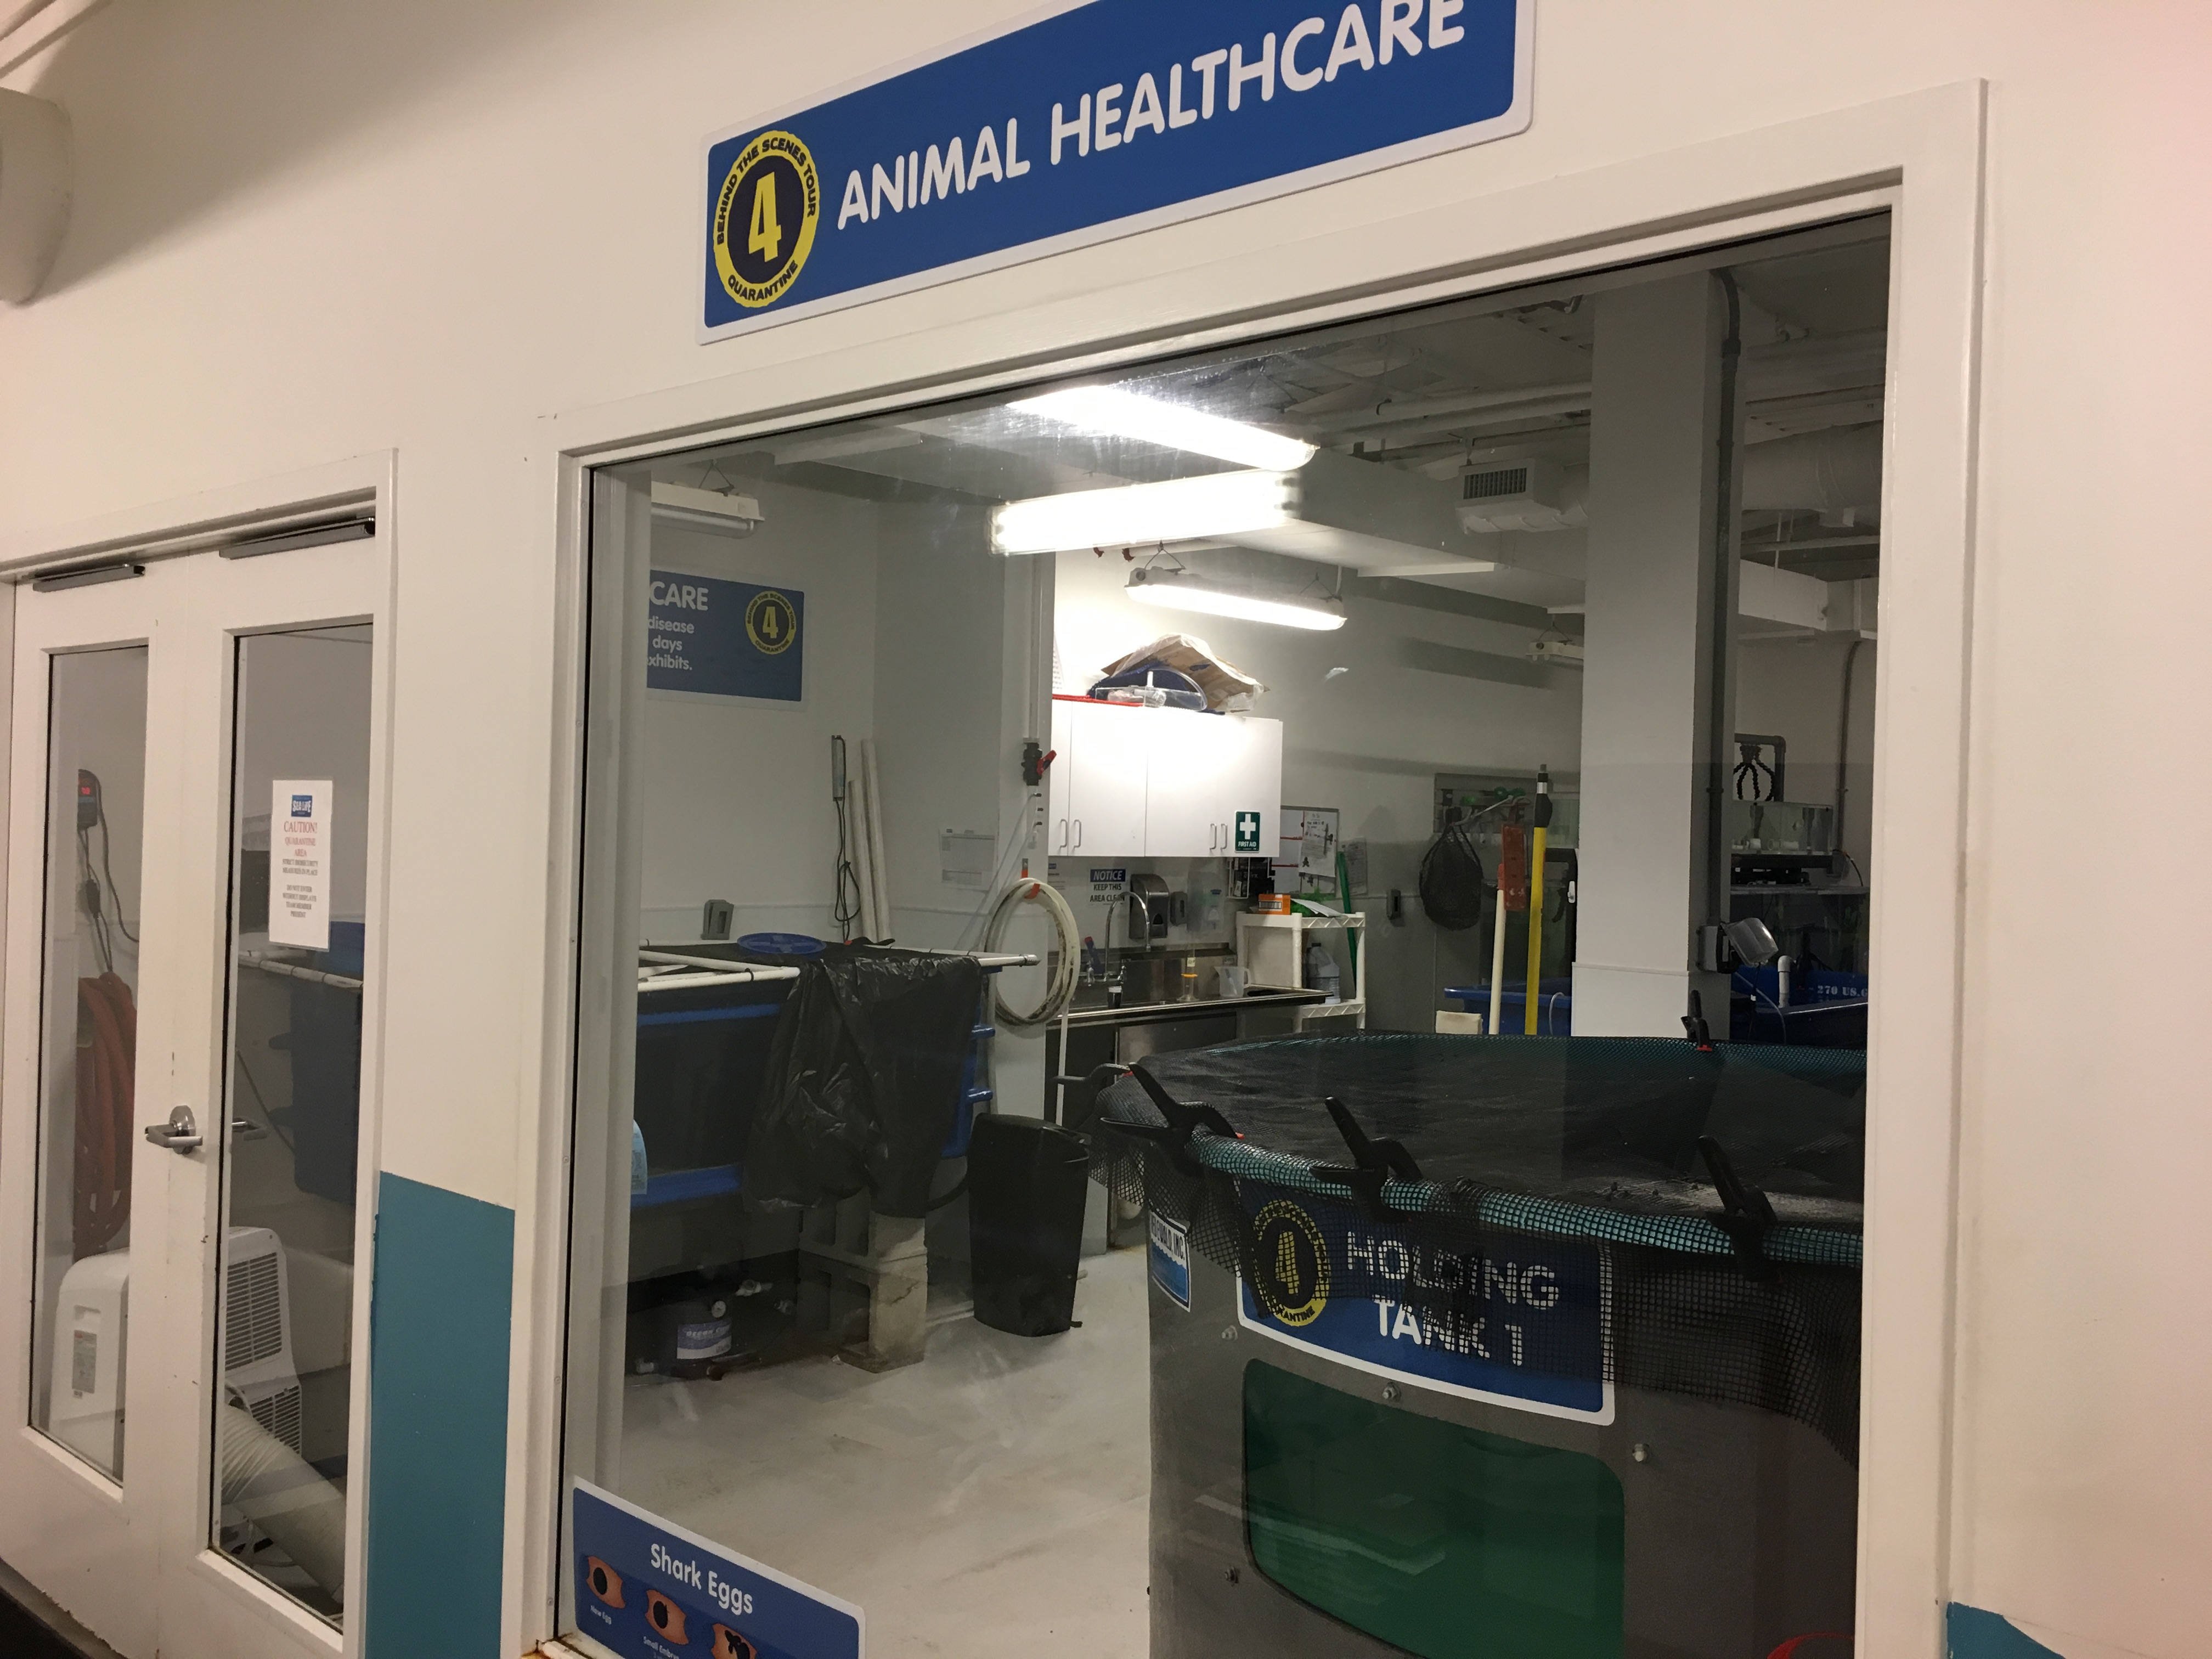

* Ask any questions you have to the designated host.
* **Note:** The doors are locked, please do not open them.
* **Note:** The mat in front of the healthcare door is full of disinfectant, so as aquarists walk in they are not bringing in any germs.
* **Warning:** The lights are bright in this area to allow aquarists plenty of light to work.
* **Warning:** Because of the kitchen area, it tends to smell “fishy” right after they prepare the food for the day.

Sensory Level *(1= low sensory stimulation, 5= high sensory stimulation)*

Guest Guidelines/Tips

2

5

4

1

1

SIGHT

SMELL

SOUND

TASTE

TOUCH











**Behind the Scenes: Animal Healthcare**

This is the fourth stop on our Behind the Scenes tour. Your tour guide will discuss how aquarists take care of animals in quarantine. You may be able to see our baby animals!



**SEA LIFE Orlando Aquarium Sensory Guide**

C:\Users\BNowak\Desktop\eye-open.png



**Behind the Scenes: Dive Locker**

This is the fifth stop on our Behind the Scenes tour. You can take the elevator or stairs upstairs. This is where your tour guide will show the equipment our divers use.

Sensory Level *(1= low sensory stimulation, 5= high sensory stimulation)*

Guest Guidelines

4

5

4

1

2

SIGHT

SMELL

SOUND

TASTE

TOUCH











**SEA LIFE Orlando Aquarium Sensory Guide**

* You may choose to take either the elevator or stairs to meet with the group.
* Don’t enter the diver room past where the host is standing.
* Don’t walk into the side rooms at the end of the hall as these are offices for back-of-house employees.
* **Warning:** The sound is very loud due to the blower in the ocean tank to create wave movement.
* **Warning:** It is very bright as the staff needs bright lighting to see everything and work efficiently.

C:\Users\BNowak\Desktop\eye-open.png



**Behind-the-Scenes: Open Ocean Tank**

This is the final stop on our Behind the Scenes tour. Your tour guide will show you to the top-side of our ocean habitats and you’ll even get to feed some of our fish!

* Bonnethead sharks
* Chely, green sea turtle
* Monty, kemp’s ridley sea turtle

Sensory Level *(1= low sensory stimulation, 5= high sensory stimulation)*

Animals to Check Out

Guest Guidelines

5

5

5

1

2

SIGHT

SMELL

SOUND

TASTE

TOUCH











**SEA LIFE Orlando Aquarium Sensory Guide**

* Do not place your hands, feet, or any body parts through the rails. Do not climb on the rails.
* Keep your hands by your side at all times. Do not touch any of the emergency equipment along the rails.
* You may choose to take either the elevator or stairs to meet with the group.
* **Warning:** The sound is very loud due to the blower in the ocean tank to create wave movement. This creates a difficulty to see the animals clearly at all times.
* **Warning:** It is very dark and lacks overhead lights. The only lights are spotlights above the tank. However, a host will be there to guide you around the rails.
* **Warning:** Sharks and rays swim close to the edge. Do not touch them.
* **Warning:** There is a fountain, water pump at the midpoint of the habitat.