About SEA LIFE London
Combining active, hands-on learning with fascinating educational talks and an opportunity to have an up close and personal encounter with a variety of sea creatures, a visit to SEA LIFE is an educational experience like no other! SEA LIFE caters for every ability level and learning style, using a unique combination of auditory, visual, and kinaesthetic learning opportunities. Children are encouraged to have supervised, hands-on contact with live sea creatures in the touch pool which is often the highlight of the trip for many children.
About Merlin Entertainments Group
Merlin Entertainments Group is the leading name in location based, quality family entertainment. Now the world's number two visitor attraction operator, it aims to deliver unique, memorable, and rewarding experiences to its 67 million visitors worldwide, through its iconic global and local brands, and the commitment and passion of its managers and employees. Merlin has over 130 attractions, in 25 countries, across three continents - Europe, North America and Asia.
Legal requirements and attraction information
Public Liability | SEA LIFE centres and Sanctuaries are covered by Public Liability Insurance to the amount of £10 million. The Policy is with Chubb European Group Limited (Policy No UKCANC33447).
Local Enforcement Agency | SEA LIFE and Sanctuaries are enforced by Lambeth Council. Please email schools@londonaquarium.co.uk if you require further information.
Rides Engineering / Maintenance | The centre does not operate any mechanical rides
Food Safety and Hygiene | 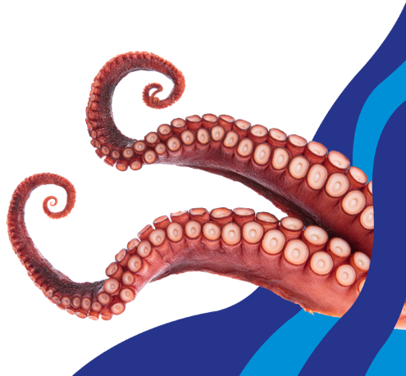  The food units operate in accordance with the Food Safety Act 1990 and are regularly inspected by the local Environmental Health Department, and undergo regular internal health and safety audits carried out by Merlin Entertainments.
Attraction Staff / Staff identification | All attraction staff wear uniforms and name badges for easy identification. A policy exists for all new staff to have  criminal record checks.
Security | The attraction has a dedicated security team who can deal with minor security issues on site. The team is  also trained to deal with emergency incidents that may arise.
COVID-19 | We've been awarded the VisitEngland ‘We’re Good to Go’ industry charter mark. This verifies that our attraction meets the Government and public health guidance on COVID-19 and that we have all the required health and safety processes in place to ensure you have a safe and enjoyable visit.
Risk assessment
Vehicle traffic | N/A.
Weather protection / Sun safety | 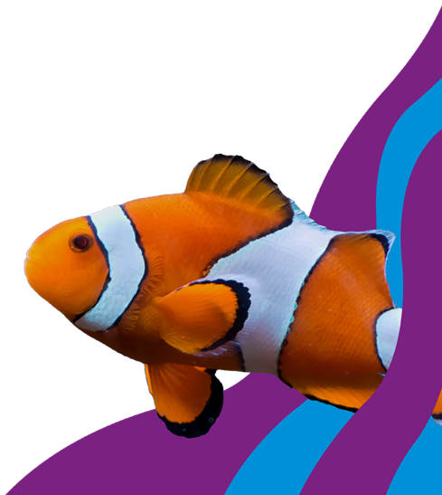  The attraction is indoors so weather protection is not required. The only exception may be when groups are asked to wait outside while tickets are collected on arrival to avoid crowding in the entrance way.
Water | There are display tanks throughout the different attractions and also touch pools; supervision is required at all  times.
Slips/ Trips/ Falls | The following hazards should be noted:  - Trips caused by looking in the display and not at the floor  - Wet flooring  - Steps and stairs
High level areas | Supervision is required and there is no climbing on the barriers.
Strobe lighting | Strobe lighting effects are used in certain areas throughout the attraction.
Reduced lighting | Care should be taken due to reduced lighting in certain areas.
Enclosed spaces | Some parts of the attractions could make individuals feel confined due to being dark, warm and humid. However there are no areas in the attraction that can be defined as a confined space.
Attraction specific risk | Creatures, stings and bites: Do not place hands into any of the display tanks. All visitors must wash their hands if they have contact with any creatures or water. Extra care is required for children sensitive to this environment.
Door entrapment | Beware of closing doors on fingers etc
Rides | N/A
Soft play areas / Play equipment | N/A
COVID-19 | We are continuing to take the necessary measures to provide a safe and hygienic environment for guests. The health and safety of our guests and staff is our absolute priority. We have implemented an extensive range of safety measures, designed to ensure a happy, safe, and healthy experience for all guests and staff. These include:  - Lower capacity – whilst legal restrictions have been lifted, we want to ensure we can still offer the best possible guest experience  - We continue to highly recommend that face coverings are worn inside our attractions  - You may continue to see Personal Protective Equipment (PPE) and clothing for some of our staff  - Continuation of enhanced cleaning, hygiene stations and hand sanitiser for guests at key locations  - You may still see increased ventilation and suggested spatial separation markings and other similar operating adjustments around the attraction
Attraction arrangements
Arrival arrangements | 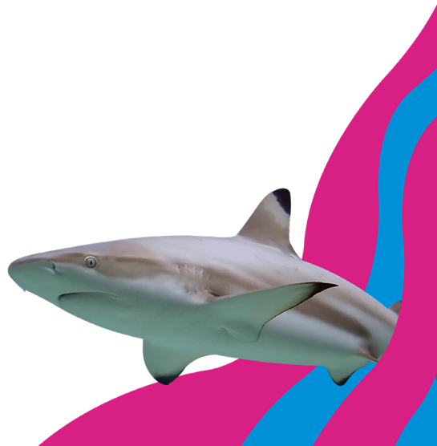  If you are bringing a group by minibus or coach and need to drop off and pick up your group you can take advantage of coach-parking bays by the London Eye, please note that space is very limited. This service is complimentary, but must be booked in advance by e-mailing coach@londoneye.com with the following details: Date of visit, time of visit (drop off and pick up times), number of guests, number of coaches, site visiting, coach company, vehicle Registration/s, driver's name. Please note that you are only permitted to use a parking bay for 20 minutes whilst you drop off and then pick up your group and you are not permitted to stay whilst the group visits SEA LIFE London.
Parking | Please go to the 'Visitor Information' pages on the website for the most convenient car park in relation to the attraction.
First aid | SEA LIFE London has a medical / first aid facility which is operated by a dedicated team of qualified first aiders. Nearest hospital: St Thomas’ Hospital
Emergency planning | SEA LIFE London has a contingency plan in the event of an emergency. The emergency plan has been developed in conjunction with the local emergency services who have regular meetings regarding emergency procedures.
Fire safety | In the event of an emergency please follow all evacuation procedures.
Wheelchair access | SEA LIFE London is fully accessible with lifts to all levels. We also have a ramp at the entrance which can be used for entry and exit into the aquarium.
Lost children | Please report to member of staff or security guard.
Unruly children | The attraction has regulations displayed at the entrance. Staff are trained to enforce these regulations for the benefit of all guests. Staff will instruct children to behave where necessary. Children should be supervised by an adult at all times.
Age / height restrictions | The minimum age restriction for children to enter the attraction without an adult is 16; any child 15 and under must be accompanied by someone over the age of 18.
Lockers / storage facilities | There are no lockers or storage facilities.
Eating facilities | SEA LIFE London does have a Schools Lunch Room onsite, however this is subject to availability and must be booked in advance. If you are unable to secure a time slot for the lunch room we recommend lunch in Jubilee Gardens, however this would be weather dependant. We are unable to add any additional times to those advertised for our Schools Lunch Room. Please note, we do not have a facility to store lunches or bags.
Welfare facilities | There are toilets located on entry, on exit of the 'Rainforest Adventure' experience and just before the experience 'Ocean Invaders'.
Additional costs | There is a retail outlet and picture booth where additional funds may be appropriate.
Attraction signposting | SEA LIFE London is a free flow attraction with a single route to take you past all of our exhibits. We would therefore recommend splitting and exploring in smaller groups with assigned meeting points at certain times. Please note: Once your class has entered the attraction you will not be able to leave and then re-enter.
COVID-19 | Before you visit:  We will be updating our social media pages and website with the latest information, keep checking back for updates and before leaving home, please check our website and social media pages for the latest information.  Should you or any member of your group start displaying any of the symptoms associated with COVID-19 please refrain from visiting. Please contact customer services should you need to amend your booking.  When you arrive:  We highly recommend face covering are worn when visiting the attraction.  Please always remain within your group, keeping a safe distance between you and other guests. Please ensure you consider your teacher to child ratio to help enforce/manage this.

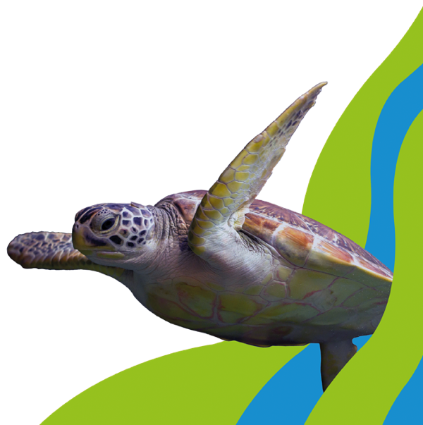
The purpose of this document is to enable schools / groups to use the information provided for the development of visit risk assessments in order to satisfy the obligations placed by the Health and Safety at Work Act and the Management of Health and Safety at Work Regulations. The above hazards have been identified as being inherent to this attraction. Merlin Entertainments Group Ltd does not accept liability for any omissions to this list. Control measures indicated are recommendations only and must be adapted / amended by group organisers. Please ensure adequate supervisors are appointed for the number in your group.

